**Screenshots of Running Program**

In the below screenshots I will demonstrate the main menu, the conversion screen for Distance, the two conversions working, converting again, trying to misinput values, the return to main menu option and quitting the program. The program will work like demonstrated for every other conversion option.

**Main Menu**

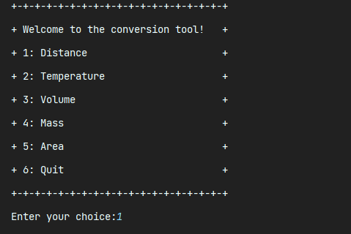

**Distance Conversion Screen**

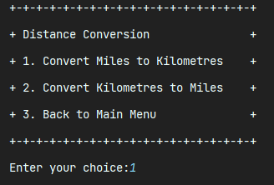

**Converting Miles to Kilometres**

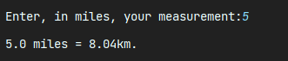

**Converting Again**

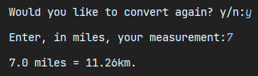

**Trying to misinput values**

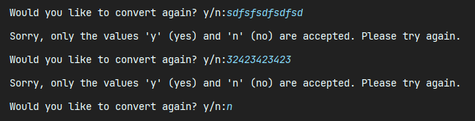

**Converting Kilometres to Miles**

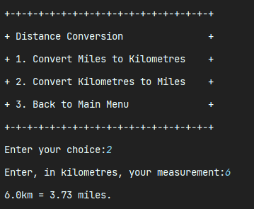

**Trying to misinput values**

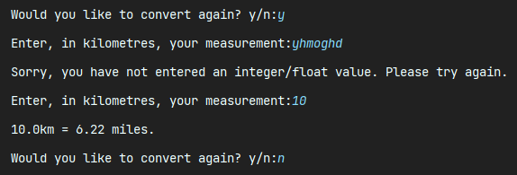

**Returning to Main Menu**

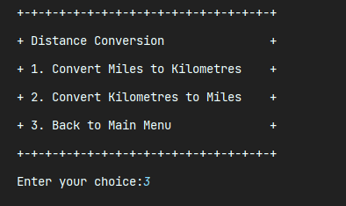

**Quitting Main Menu**

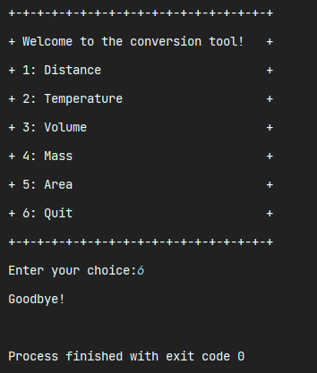

**Screenshots of Test Files**

In the below screenshots I will demonstrate all the tests in the program which are responsible to ensure that the conversion functions operate as expected. We opted to use Pytest when it came to the tests.

**test_area.py**

Testing the Area class of the program

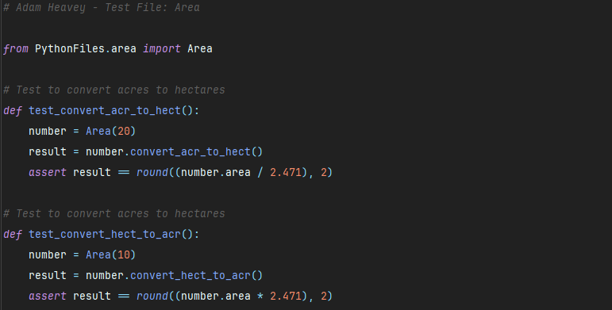 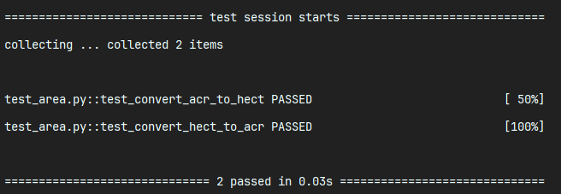

**test_distance.py**

Testing the Distance class of the program

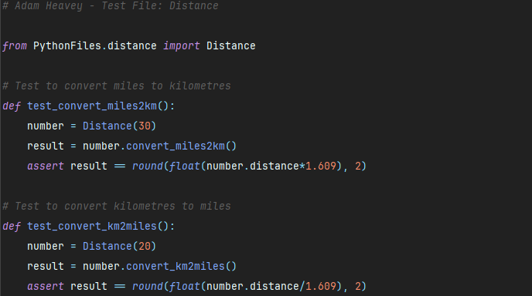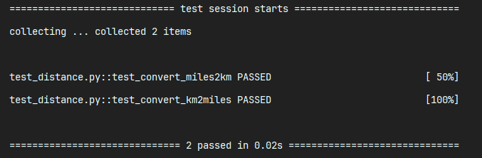

**test_mass.py**

Testing the Mass class of the program

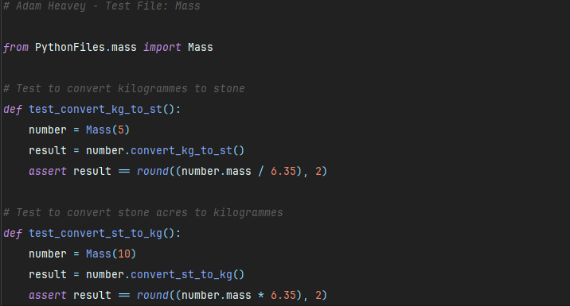 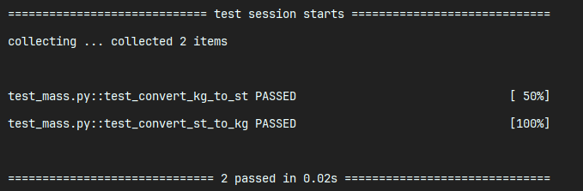

**test_temperature.py**

Testing the Temperature class of the program

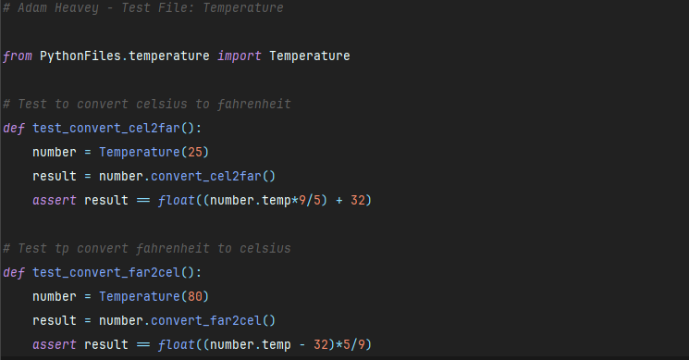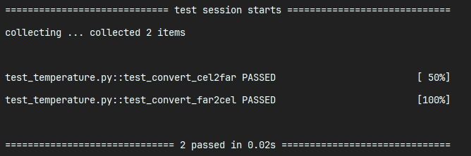

**test_volume.py**

Testing the Volume class of the program

